**Topics: Normal distribution, Functions of Random Variables**

1. The time required for servicing transmissions is normally distributed with *μ* = 45 minutes and *σ* = 8 minutes. The service manager plans to have work begin on the transmission of a customer’s car 10 minutes after the car is dropped off and the customer is told that the car will be ready within 1 hour from drop-off. What is the probability that the service manager cannot meet his commitment?
2. 0.3875
3. 0.2676
4. 0.5
5. 0.6987

Ans : Given data mean(u)= 45 ,std.dev=8, time(X=1hr or 60mins)

As the work begin after 10 min so, the average time increase from 45 +10 = 55

Probability that the service manager meet his commitment=(X-u)/std.dev

= (60-55)/8

= 5/8

=0.625

So, Probability that the service manager cannot meet his commitment= 1- 0.625

=0.265

OR

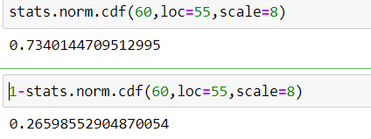

**B option is correct.**

1. The current age (in years) of 400 clerical employees at an insurance claims processing center is normally distributed with mean *μ* = 38 and Standard deviation *σ* =6. For each statement below, please specify True/False. If false, briefly explain why.
2. More employees at the processing center are older than 44 than between 38 and 44.
3. A training program for employees under the age of 30 at the center would be expected to attract about 36 employees.

Ans : (A) P(X>44)

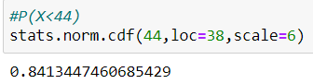

So, people above 44 is =100-0.84=15.87% ~ 63 out of 400

People for age 38 0r P(X>38)= 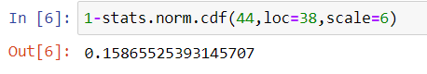

People between 38 and 44 =84.13-50=34.13% ~ 137 out of 400

Hence more employees at processing centre is older than 44 than between 38 and 44 **is FALSE.**

(B) P(X<30) =9.12% ~ 36 out of 400

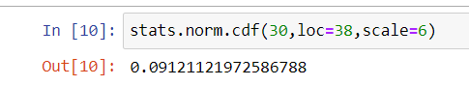

Hence a training program for employees under age of 30 at the centre would be expected to attract about 36 employees which is **TRUE**.

1. If *X1*~ *N*(μ, σ2) and *X*2 ~ *N*(μ, σ2) are *iid*normal random variables, then what is the difference between 2 *X*1 and *X*1 + *X*2? Discuss both their distributions and parameters.

Ans: 2*1 is simply a large scale version of the random variable X2 if X1 is normally distributed then 2*1 is also normally distributed ,the associates sum and the random samples are exactly normal with the appropriate parameter.

1. Let X ~ N(100, 202). Find two values, *a* and*b*, symmetric about the mean, such that the probability of the random variable taking a value between them is 0.99.
2. 90.5, 105.9
3. 80.2, 119.8
4. 22, 78
5. 48.5, 151.5
6. 90.1, 109.9

Ans: Given mean=100, std.dev=20, P(a<X<b)=0.99

Symmetric values for the standard normal distribution such that area enclosed is .99.

Area 0.005 excluded from each side of the tails.

So, We want to find the 0.5th and 99.5th percentile Z-Score.

Z value at 0.5th percentile and 99.5th percentile are respectively.

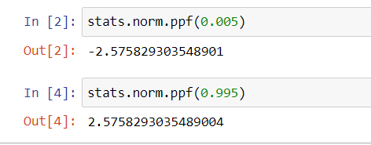

Z=(x-u)/std.dev=(x-100)/20

x =20z+100

a = - (20*2.576) + 100

= 48.5

b = (20*2.576) + 100

=151.5

Two values symmetric about for the given std. normal distribution are [ 48.5 , 151.5 ].

**D option correct**

1. Consider a company that has two different divisions. The annual profits from the two divisions are independent and have distributions Profit1 ~ N(5, 32) and Profit2 ~ N(7, 42) respectively. Both the profits are in $ Million. Answer the following questions about the total profit of the company in Rupees. Assume that $1 = Rs. 45
2. Specify a Rupee range (centered on the mean) such that it contains 95% probability for the annual profit of the company.
3. Specify the 5th percentile of profit (in Rupees) for the company
4. Which of the two divisions has a larger probability of making a loss in a given year?

Ans : ( A) Company profit=Profit1 + Profit2

profit ~ (12,52)

mean (u)=12, std.dev=5

95% of the probability lies between the 1.96 standard deviation of the mean.

So, range is [12-1.96*5, 12+1.96*5]=[2.2,21.8]

**In Rupees =99 rupees,981rupees**

(B) 5th percentile of profit for company

=12 – 1.644*5

=10.3551

Profit in **Rupee** =10.355*45

=**465.975 rupees**

(C) 1st distribution has larger probability of making loss in a given year.